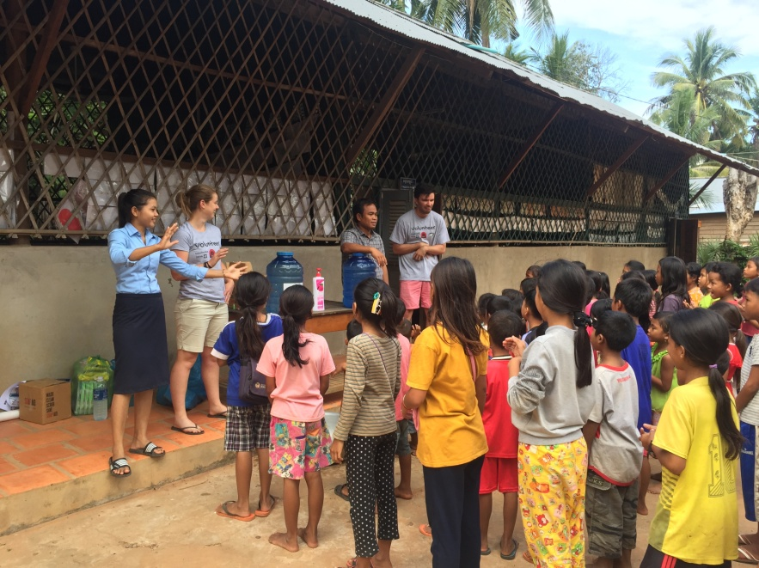
GROWING CAMBODIA:
Health & Sanitation Program
November 2016
Dr Stacey Davie, Dr Andrew Lewandowski & Rosie Bourke

SCHOOL VISITS

Beng School
- The school appears in good condition, with clean facilities and working water / electricity. The local elders are supportive of the education programs in place, and were enthusiastic in their support for the hygiene models.
- The elders have also been provided with toothbrushes in an attempt to provide positive role models and reinforce
- Teachers were very well organised, confident and ran classes very smoothly

Oroluos School
- The school is in great condition with working water, electricity and toilet.
- The two female teachers were great at working with the girls, they also learnt about puberty and menstruation and were able to teach the girls by the end of the classes that we conducted here.
- The male teachers were also very confident and great at teaching

Kok Beng School
- Electricity has been connected and there is a toilet and well for ongoing water supply
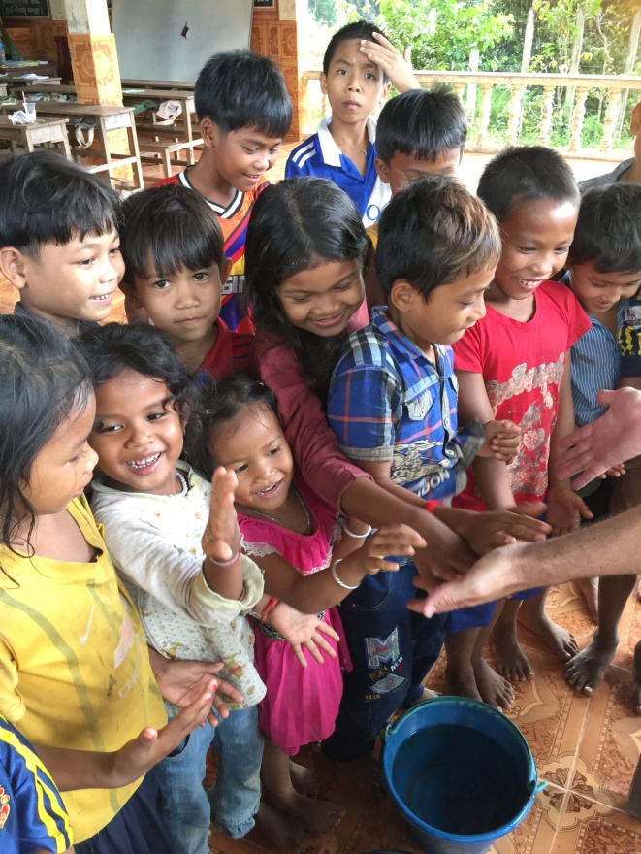
- Again, great teachers!
- So much growth since my last visit in 2012, but very structured, organised & well maintained
- Some of the children I met 4 years ago I could see vast improvements in their English skills

WHAT WE DID:
- Hygiene and Sanitation modules
- Sexual Health modules (Oroluos)

- Hygiene/Sanitation Modules

Our handwashing and tooth brushing education was well received by the children. While most understood how to brush their teeth, few neither had their own brushes nor understood the need for twice daily brushing.

LESSONS:
Students were educated according to our hygiene and sanitation module. This involved:
- Introductions to germs: where they can be found, the harm they cause and how they can make us sick
- There was also a separate talk and posters on the symptoms, signs and treatment of gastro
- Glitter was used as a model to demonstrate how germs can be passed from one person to another easily, and subsequently students were taught how to effectively wash their hands to remove these germs
- The need to wash hands particularly after playing outside with animals or dirt, after using the toilet and prior to handling food was emphasised
- A new school rule was made: children must wash their hands before entering the classroom
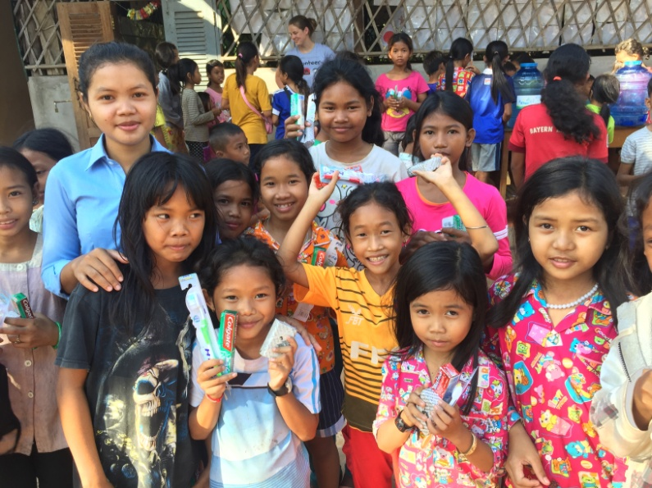
- Teachers were also educated on the importance of hand-washing and the importance of re-educating and reinforcing these rules to the children.
- Teachers must ensure that daily hand-washing occurs before each class

DONATIONS:
- Each child took home a toothbrush and toothpaste set (donated by Growing Cambodia) and a bar of soap (500 bars of soap were kindly donated by Eco Soap Bank)
- Each school received (through ASHA Charity) a large dispenser of liquid soap per classroom, as well as a 4L bottle of detergent to continue to refill it (by diluting the detergent, this is common practice in Cambodia as soap is quite expensive). Teachers were taught on how to refill these dispensers.
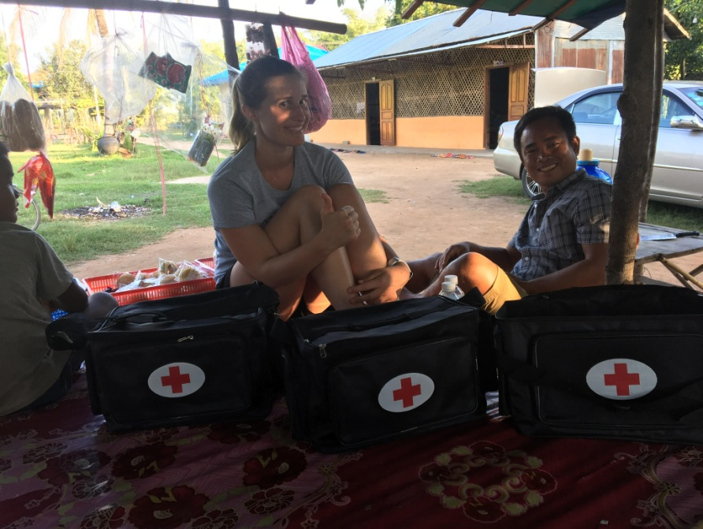
- Buckets are available at each school to fill with water each day to ensure children have the facilities to wash their hands each day
- Each school also received a first aid kit (donated by ASHA) and teachers were taught how to use each of the items.
- These consisted of a first aid bag &:
    - 100 rehydration salts (gastro)
    - Band-Aids + gauze
    - Ibuprofen + Paracetamol
    - Alcohol + peroxide wash + betadine (wounds)
    - Sports tape
    - Thermometer
    - Cling wrap (for burns

2) Sexual Health Modules- Oroluos School

The boys were separated from the girls to facilitate their learning in an uninterrupted environment.

THE GIRLS:
- Sexual education (through a power point presentation and the teachers translating)
  - Puberty: the changes to the body and mind
  - Periods: why we get them, how to care for yourself during this time
  - The importance of condoms for STI prevention and birth control.
- The girls had many questions as this topic is not one that is often discussed in the village and the girls were very glad to hear that they were not alone, that this same thing occurs to all girls in their village, as well as all girls worldwide
- Girls who had reached puberty were also given a ‘‘Days for Girls’ kit (40 created and donated by Nola Kemp and a group of Australian women) and educated on the use and care of these. These kits are 5 reusable pads with a washer, soap and a carry bag. The girls were shy to begin with but soon were lining up to learn how to use them and really were so grateful as they soon realised how much money could be saved each month and the convenience of the kits.
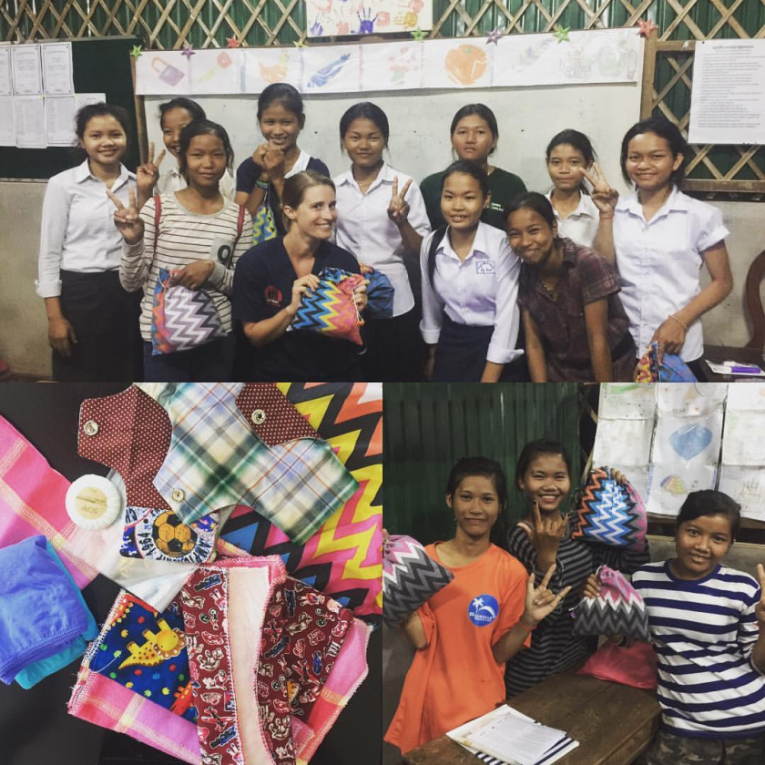
- Being able to provide ongoing donations of these Days for Girls kits is something that would be very welcomed and very useful in these villages. I plan to create a specific group within Growing Cambodia to continue to make the packs and send them over- for education to occur with each distribution of packs by the female teachers at the school.
- The two female teachers have a copy of the power-point presentation on puberty and periods and by the end of the day they were competent in teaching the girls on their own with the aid of the slides.
- A booklet on puberty in Khmer (their local language) was also given to the school on USB to distribute to each of the girls.
BOYS:
- While the discussion of sex before marriage, contraception and sexually transmitted diseases has been taboo since the Khmer Rouge occupation, the village elders and school manager Sopheak felt the boys would benefit from an introductory lesson from our male doctor Andrew
- The boys discussed the importance of hygiene, the changes in the body that occur during puberty such as hair growth, sweat, acne and erections, and the hormonal influences on emotions and desires that require insight and control.
- Condom importance for both birth control and STI protection was stressed, and application was discussed and demonstrated on a representative model.

SUMMARY
These health lessons were overall very successful; we left feeling that we had made a difference in terms of awareness and maintenance of hygiene and sanitation.

Ongoing follow up:
- Hopefully a relationship can be formed with Eco Soap Bank to ensure children always have access to affordable soap: the aim is to have a local woman selling bars of soap near each school (Steve and Sopheak to continue with this project)
- Volunteers through Growing Cambodia can ensure children are washing their hands before each class and there is enough supply of soap/dispensers/buckets to allow this (these can be purchased from any grocery store in town)
- Volunteers can also ensure that the first aid kits are stocked and teachers are aware of how to make use of the items in the kits (we can re-stock these with things from Australia- cheaper to buy here)
- Ongoing supply of toothbrushes/toothpaste by growing Cambodia +/- refresher education
- Women in Australia can continue to make ‘Days for Girls’ kits for volunteers to take over. Two female teachers at Oroluos can continue education on use of these or volunteers can help with the aid of the presentation we left at the school
  - This will be an ongoing project that I am happy to focus on with Nola Kemp and Ella and whoever else would like to help out!

